**Jemma Johnston**

**Cohort E20**

**PDA: Analysis & Design**

**AD:1 Use Case diagram**

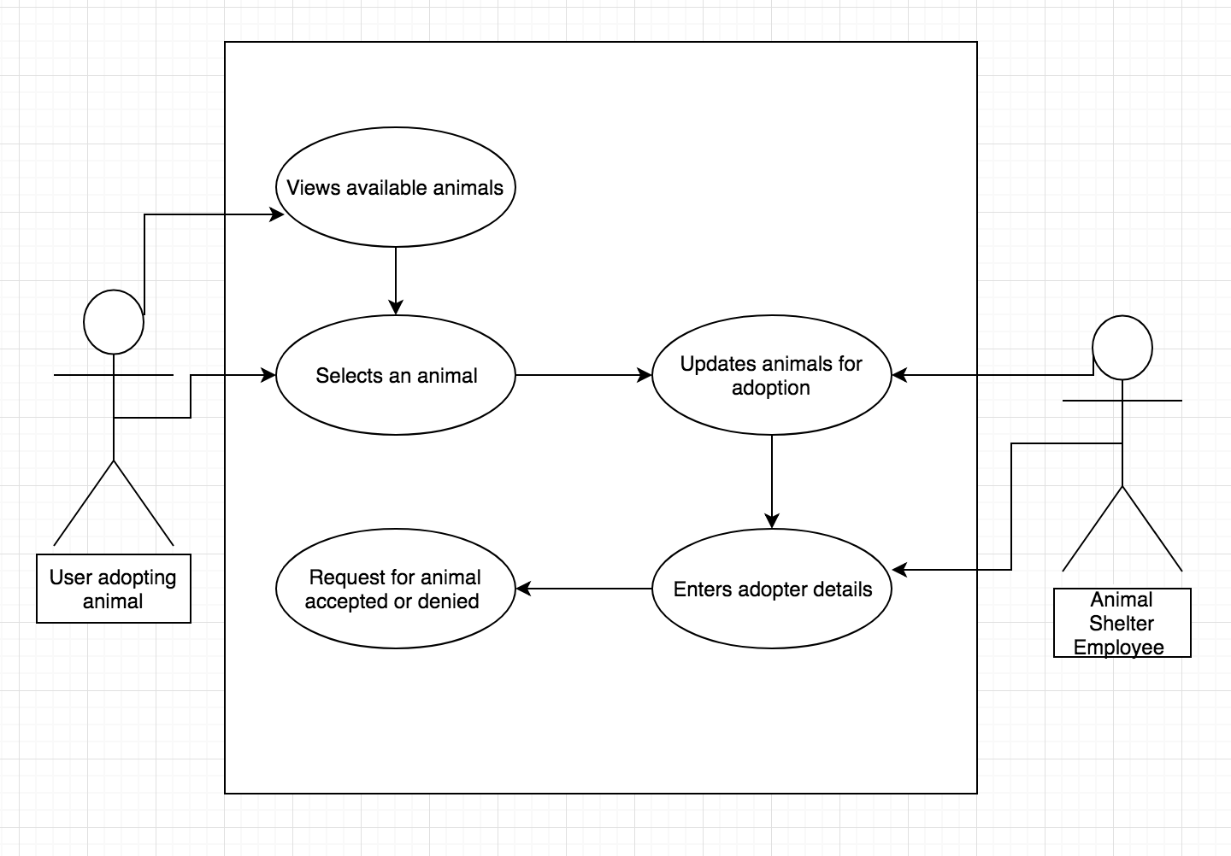

**AD:2 Class Diagram**

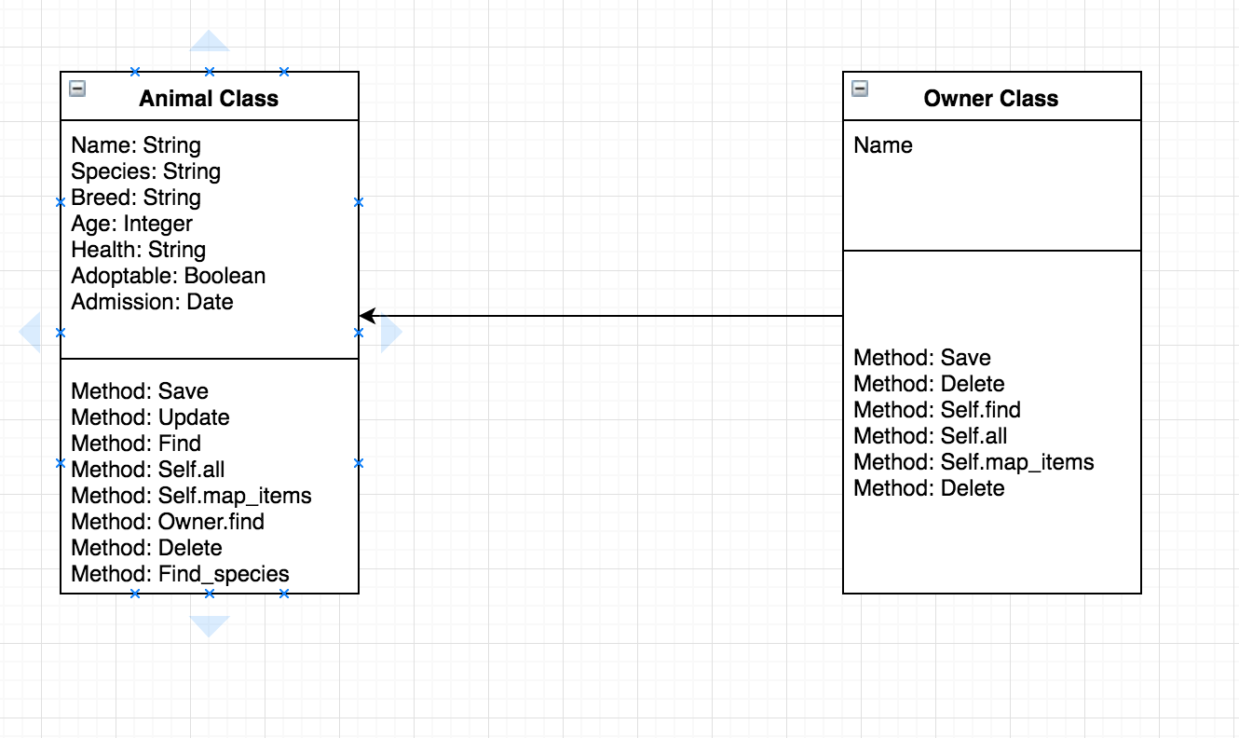

**AD:3 Object Diagram: One to Many** 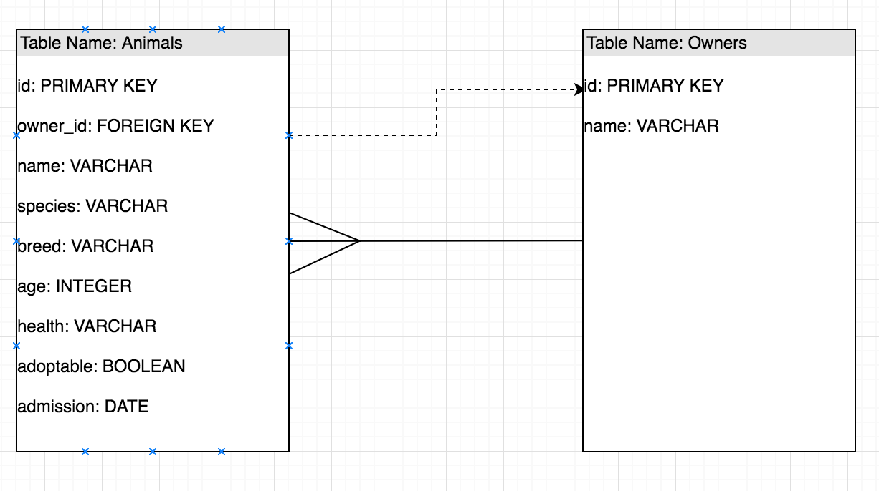

**AD:4 Activity diagram**

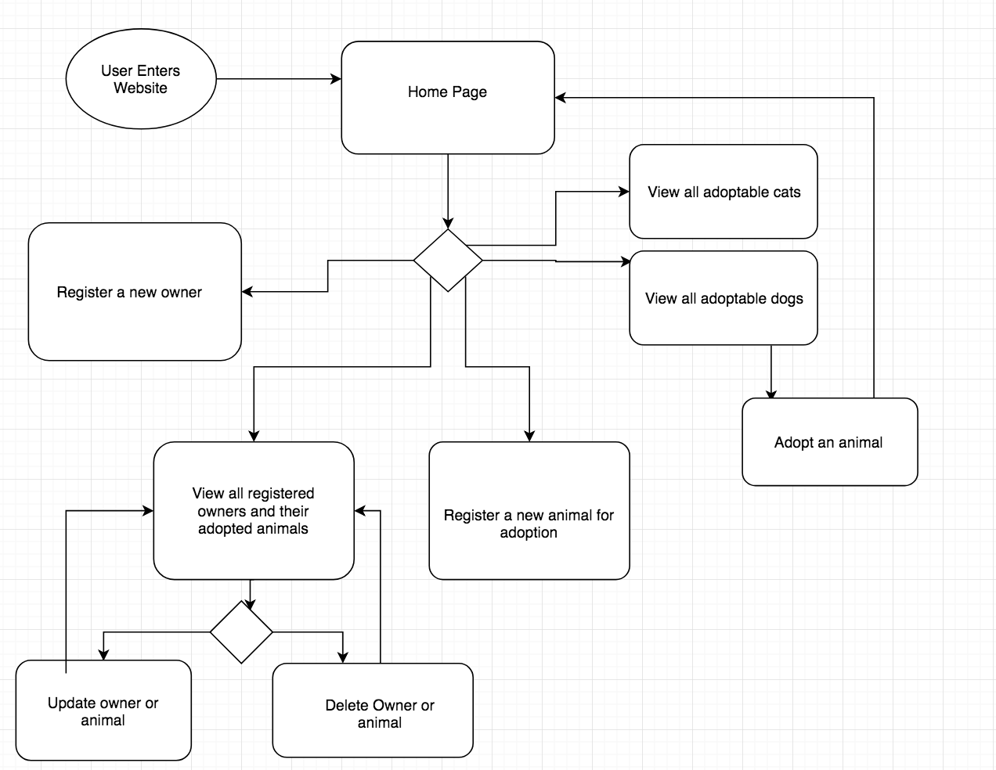

**AD:5** An Inheritance Diagram

**AD:6** Produce an Implementations Constraints plan detailing the following factors:

● Hardware and software platforms

● Performance requirements

● Persistent storage and transactions

● Usability

● Budgets

● Time